

National Textile University
Department of Computer Science
Subject:
Operating System

Submitted to:

Sir Nasir Mehmood

Submitted by:
Hafsa Amjad

Reg. number:
23-NTU-CS-FL-1162

Semester:
5th- A

Docker LAB_3

Task_01
Code:
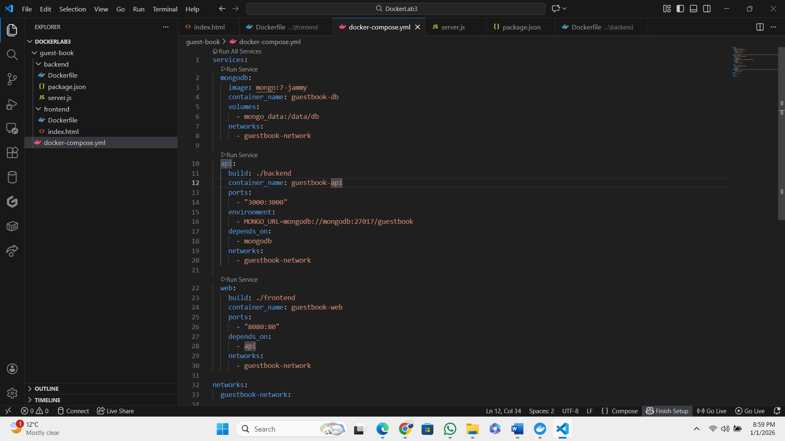

Task_02:
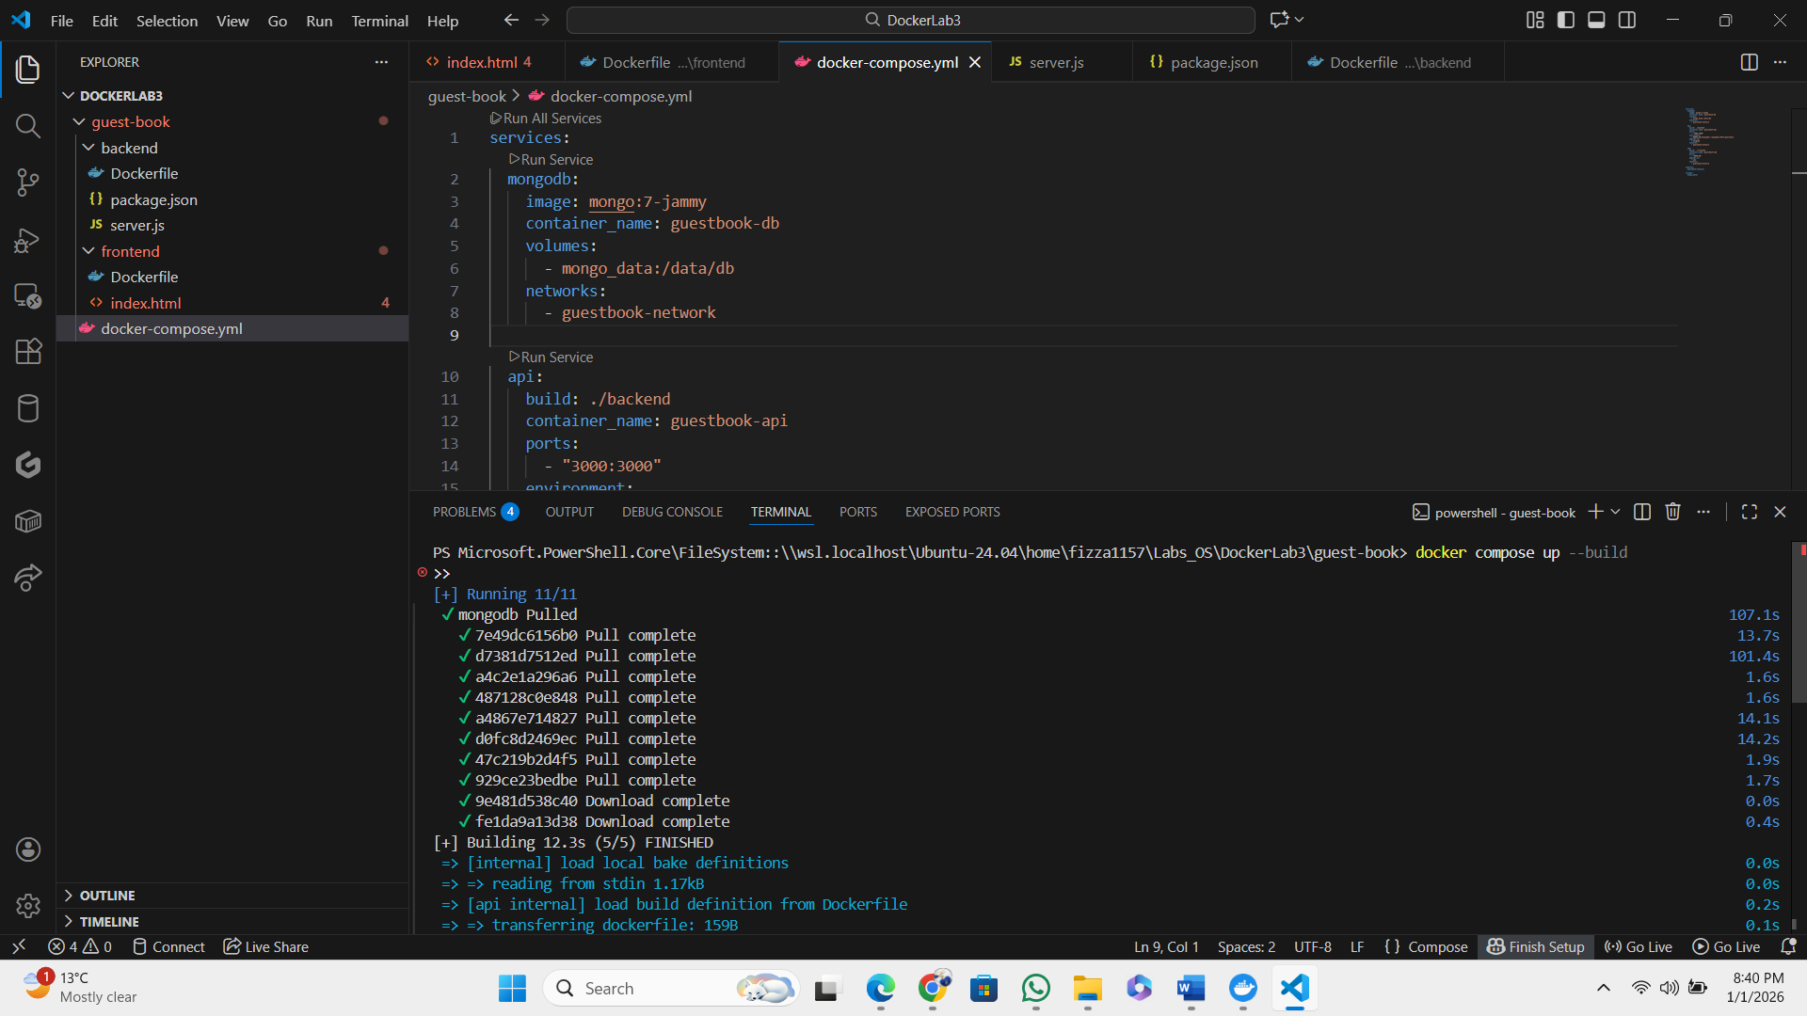

Task_03:
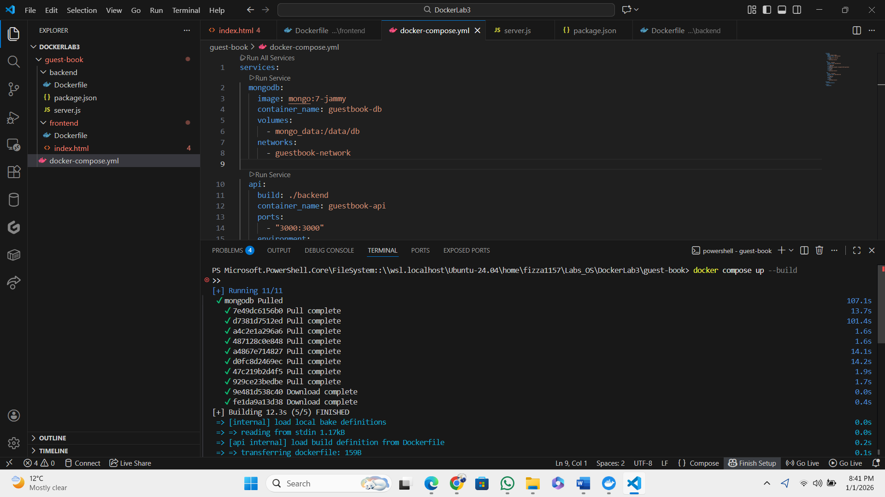

Task_04:

